**What is normal blood pressure?** Blood pressure is measured as two numbers. The higher number is called the systolic and lower number the diastolic. Blood pressure It is usually written as systolic/diastolic and is measured in millimetres of mercury (mmHg).

On average, a normal level of home blood pressure is taken as less than 135/85mmHg.

**Understanding the measurement?** Home blood pressure measurements may vary from reading to reading.

Blood pressure might be quite high, particularly in a stressful emotional situation or during a panic attack, severe pain, etc. Blood pressure also usually rises during exercise.

Sometimes blood pressure can be quite low after a long rest or after intensive physical exercise.

Measurements on “single occasions” have little value and may not be representative of the “usual” level of blood pressure of an individual at home.

High blood pressure in a single measurement should not be alarming unless very high values persist after a sufficient period of rest or are accompanied by severe symptoms (e.g. breathlessness, chest pain, arm or leg weakness, difficulty to speak).

Elevated self-monitored blood pressure at home is not in itself an indication for treatment and we will advise on if and when treatment is indicated.

In some cases, self-measured home blood pressure might be much lower than measurements taken by the doctor or nurse in the office or clinic. This phenomenon is not uncommon and is known as *“white coat hypertension”.*

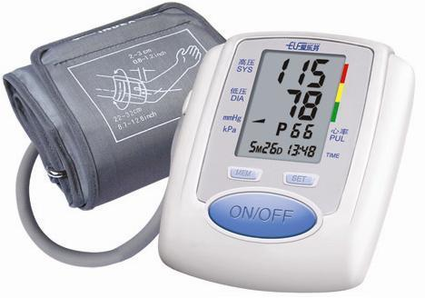On the other hand blood pressure might be low in the clinic whereas self-measured blood pressure at home is high. This is called “*masked” or “reverse white coat hypertension”)*.

These conditions require careful evaluation and sometimes further investigations such as 24h ambulatory blood pressure monitoring may be recommended to decide whether or not treatment is necessary.

**A Guide to Home Blood Pressure Measurement**

**Dr Richard Bogle**

**Consultant Cardiologist**

**St Helier Hospital**

Home monitoring is increasingly used in many countries and is now recommended by the European Society of Hypertension as part of the assessment and treatment of patients with high blood pressure.

The measurements provide a more precise assessment of blood pressure and enable accurate adjustment of medication. This is because home blood pressure measurement can be performed in the intervals between visits to outpatient clinics and they are made when the patient is more comfortable and relaxed.

**Which machine?** Not all of the machines have been properly tested and proved to be accurate. Up to date information about validated devices is available from the British Hypertension Society website ([www.bhsoc.org](http://www.bhsoc.org)).

An automated device which measures blood pressure using an upper arm cuff is preferred. A memory capacity, which automatically stores the measurement, is useful but not essential. My recommendation is the Lloyds Pharmacy LBP1 machine which costs £29.99. This machine is validated by the European Society of Hypertension and stores the last 60 readings.

**Which cuff size?** You need to make sure you have the appropriate cuff size to fit your arm otherwise the measurements will not be accurate.

There is a bladder inside the cuff and it should encircle 80-100% of the arm. If the cuff is too smaller it will underestimate your blood pressure whereas if it is too large it will overestimate it.

*Monitor cuff sizes guide*

|  |  |  |
| --- | --- | --- |
| Arm (cm) | Arm (Inches) | Cuff size |
| 18-22 | 7.1-8.7 | Small |
| 22-32 | 8.8-12.8 | Medium |
| 32-45 | 12.9-18.0 | Large |

Most monitors come with a medium sized cuff. Make sure you get the right sized cuff when you buy your machine.

Your blood pressure monitor will need to be re-calibrated at least once every 2 years to be sure it gives you accurate results.

**How to measure blood pressure** When you first measure your blood pressure you should do it in the left and then the right arm.

There may be slight differences between the two. You should note which arm has the higher pressure and then measure your blood pressure in that arm in the future.

Blood pressure should be measured after at least 5 minutes rest and after at least 30 minutes without smoking or ingesting caffeine (e.g. tea, coffee, cola).

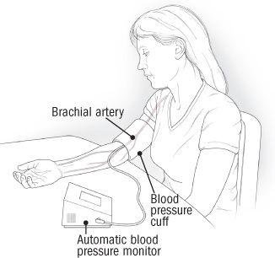During the measurement you should sit still with your back comfortably against a chair and your arm resting on a table. You should not talk during the measurement and you should not have your legs crossed.

The cuff should be wrapped snuggly around your upper arm with its center directly over the brachial artery. Most cuffs have a marker indicating the centre of the cuff. The lower edge of the cuff should be about 2-3cm above the bend of your elbow. The cuff should be at the level of your heart during the measurements.

**How often should blood pressure be measured at home? F**or blood pressure assessment and to check the effects of medication blood pressure should be measured over 7 days.

On each day a measurement should be made in the morning (soon after waking and before tablets, if you are on treatment) and in the evening. On each occasion 2 measurements should be taken 1 minute apart.

The results should be noted in a logbook immediately after measurement.

The average of the 7 days measurements should be calculated after discarding measurements on the first day. In other words 12 measurements are averaged. This 7-day schedule should be followed before each follow-up visit Measurements in stressful conditions can be misleading and should be avoided.

Over use of blood pressure measurement and self-adjustment of treatment (take extra pills or omitting doses) on the basis of home measurements should also be avoided